Multi-Dimensional Array Exercise

Create an application that checks whether a 6x6 Sudoku solution is correct or incorrect.

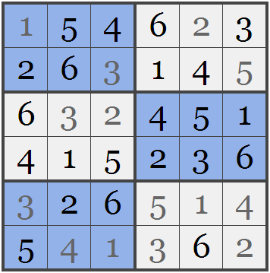
The rules of a 6x6 Sudoku are similar to the 9x9 Sudoku.
Each row or column must contain the digits 1 through 6 only once. Further more each 2x3 sub regions must contain the digits 1 through 6 only once.
The solution is read in from a formatted text file called sudoku.txt, the column entries are separated by a space, and the row entries are separated by a new line. A sample input file for the 6x6 Sudoku above is as follows:

1 5 4 6 2 3
2 6 3 1 4 5
6 3 2 4 5 1
4 1 5 2 3 6
3 2 6 5 1 4
5 4 1 3 6 2

Your application must determine if the solution is correct or one reason why the solution is incorrect (eg. Row 1 has two occurrences of the digit 3, The digit 8 is not a valid input, etc)

